1. ***USE CASE DIAGRAM:***

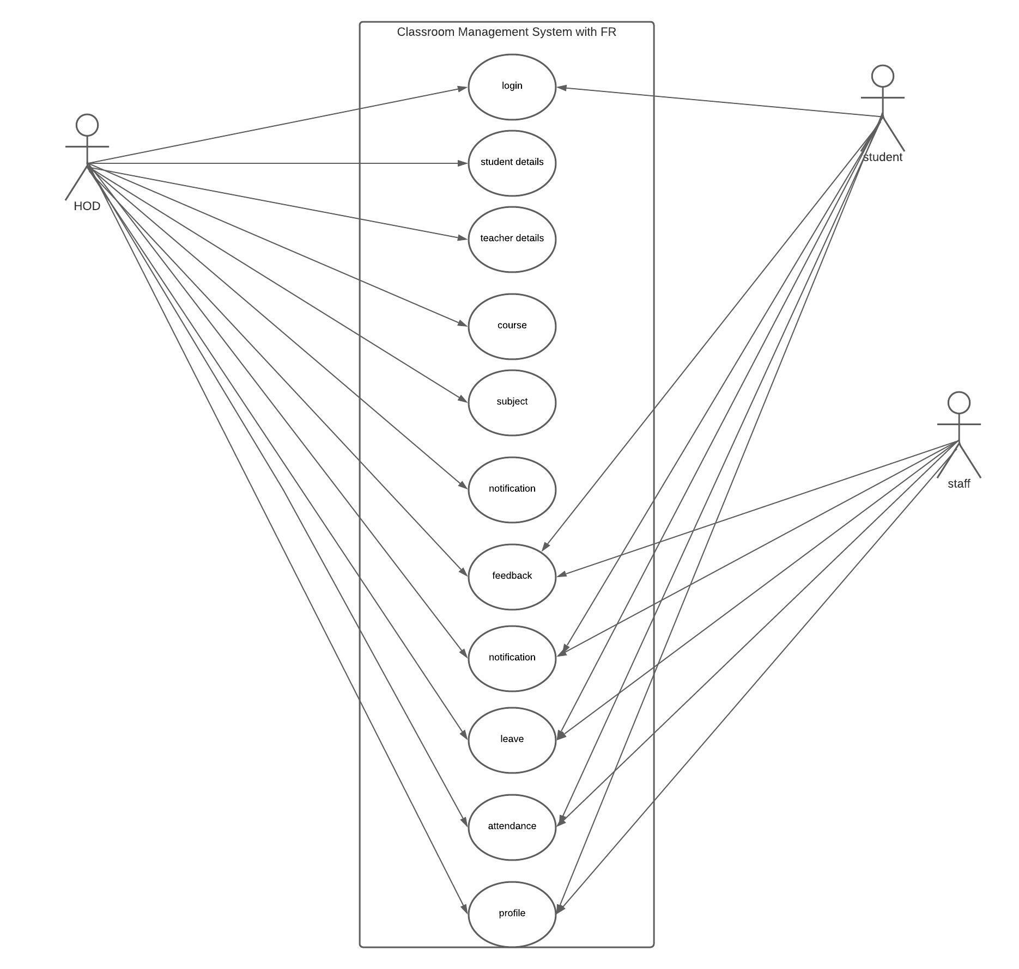

1. ***CLASS DIAGRAM:***

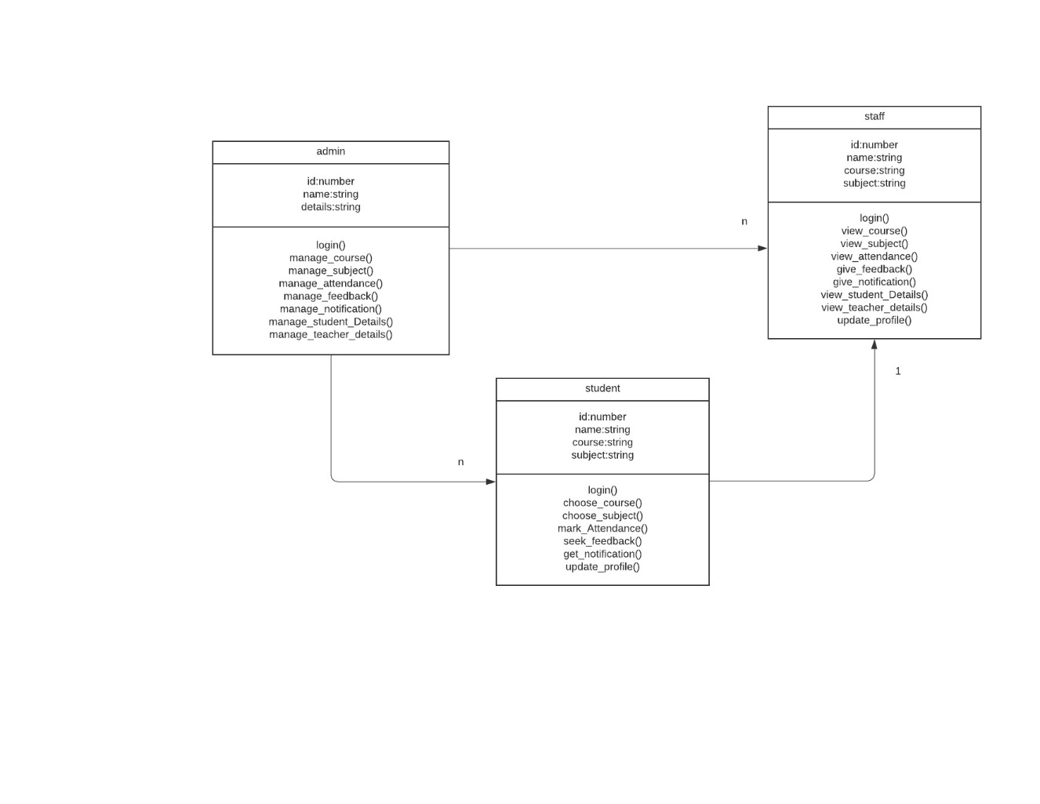

1. ***OBJECT DIAGRAM:***

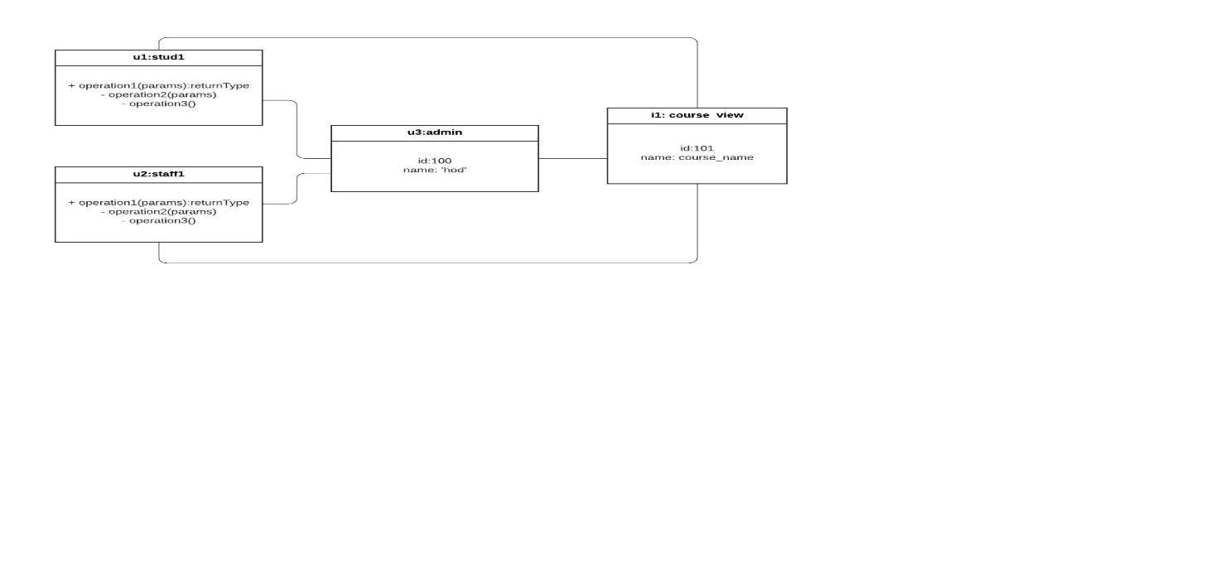

1. ***COMPONENT DIAGRAM:***

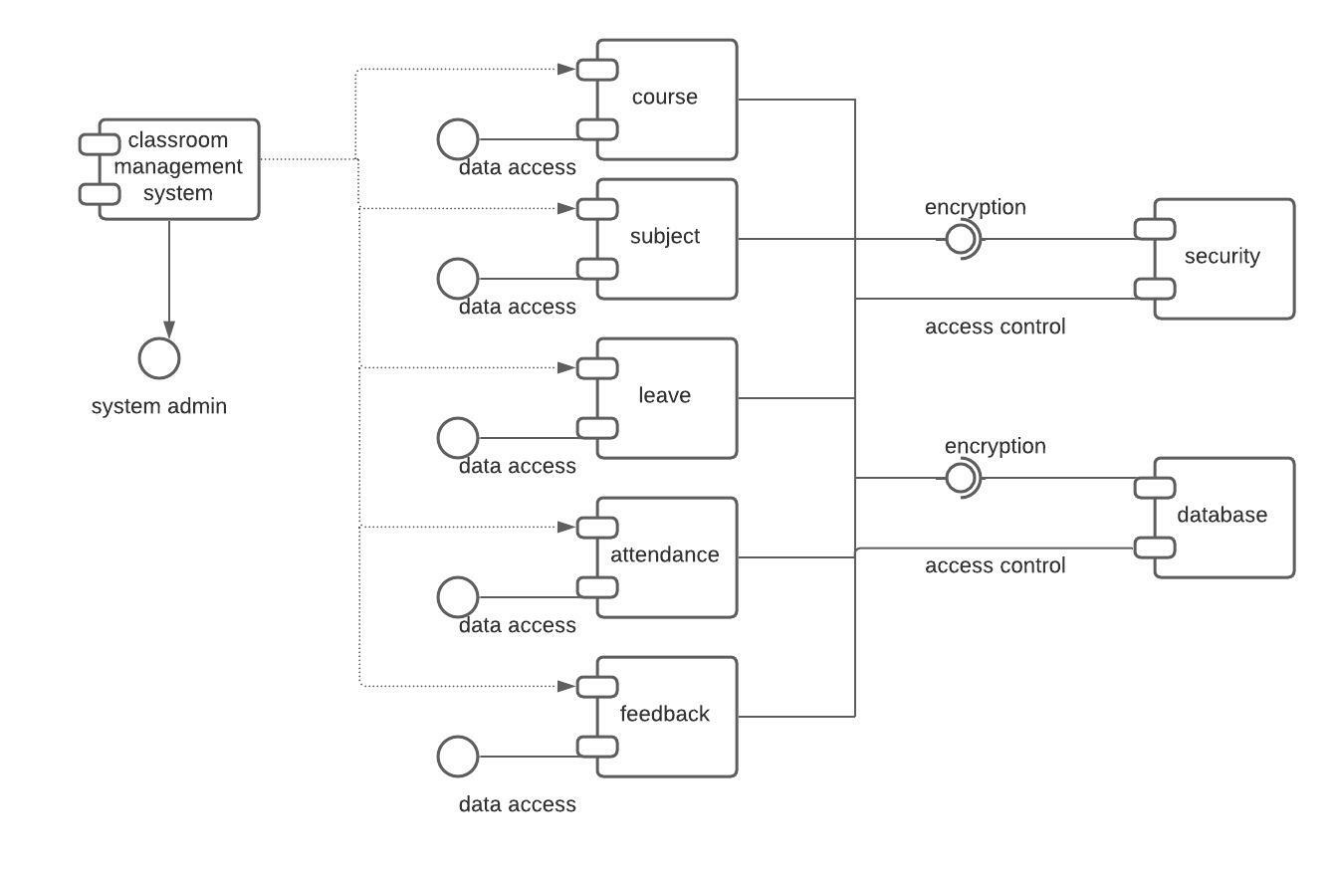

1. ***Sequence Diagram***

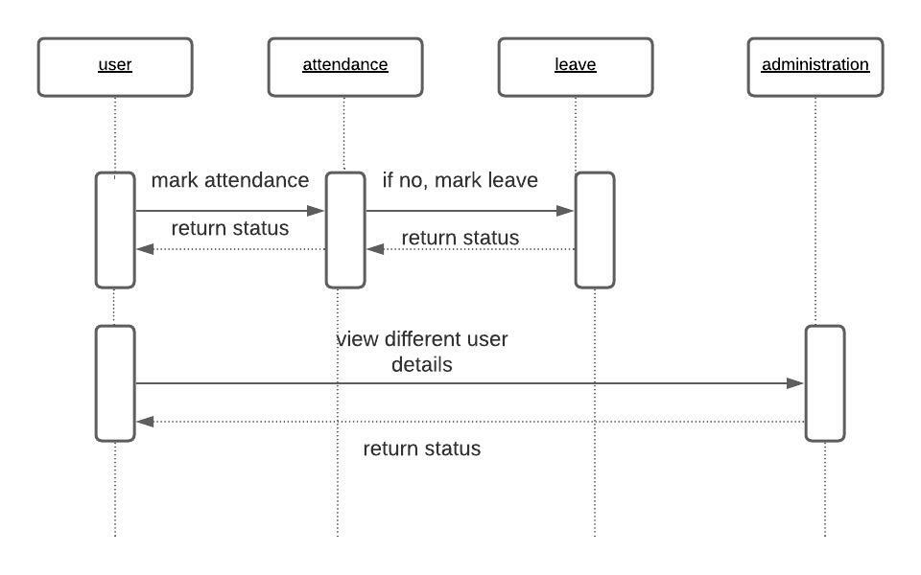

1. ***Collaboration Diagram***

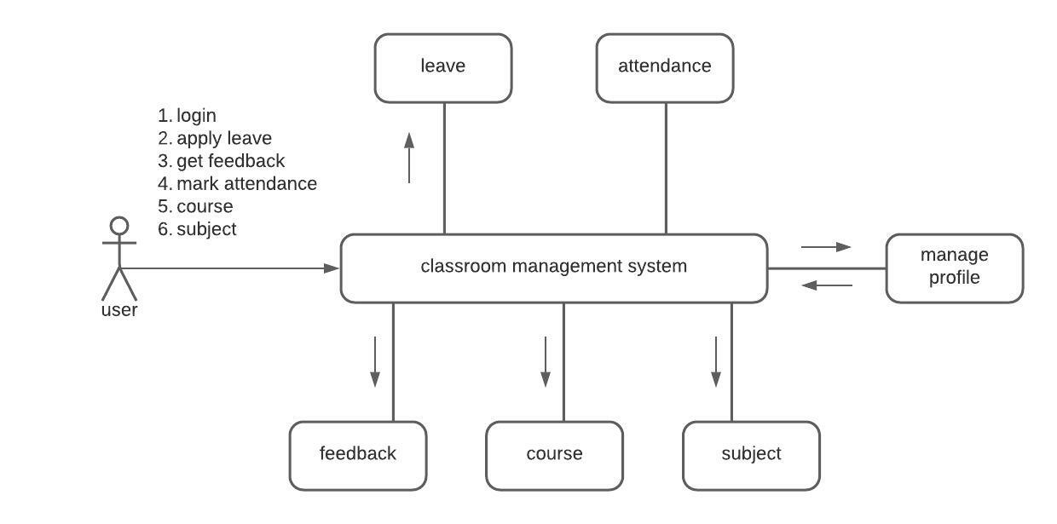

1. ***State Chart Diagram***

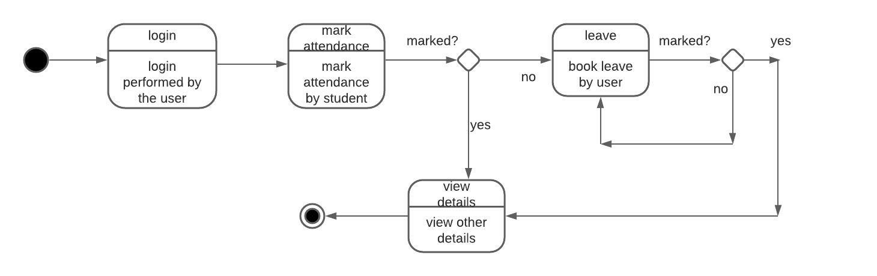

1. ***Activity Diagram***

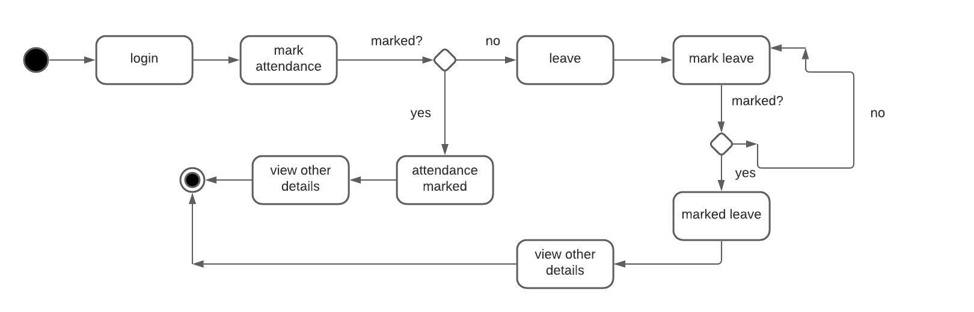

1. ***Deployment Diagram***

